Add field to MB51

Path: SPRO -> Materials Mgmt -> Inventory Mgmt & Pyhsyical Inv -> Reporting -> Define field selection for material document list.

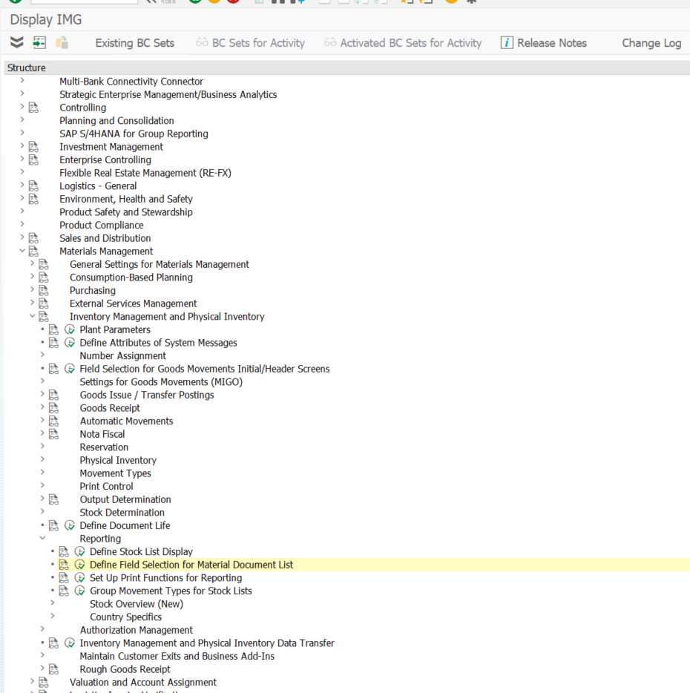

Add field MSEG-SAKTO, choose output only

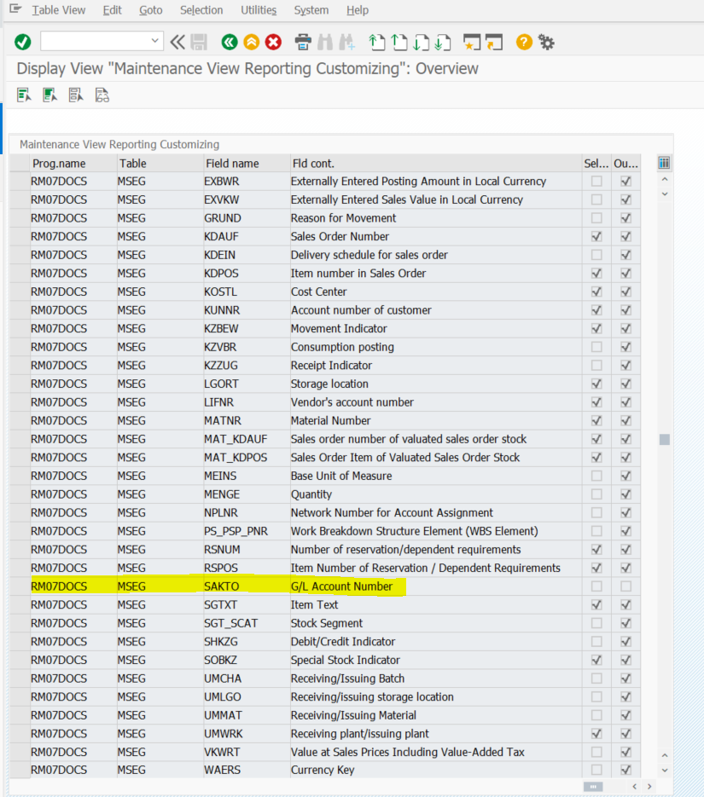

in program of MB51 will display that field

Run report MB51 to regenerate

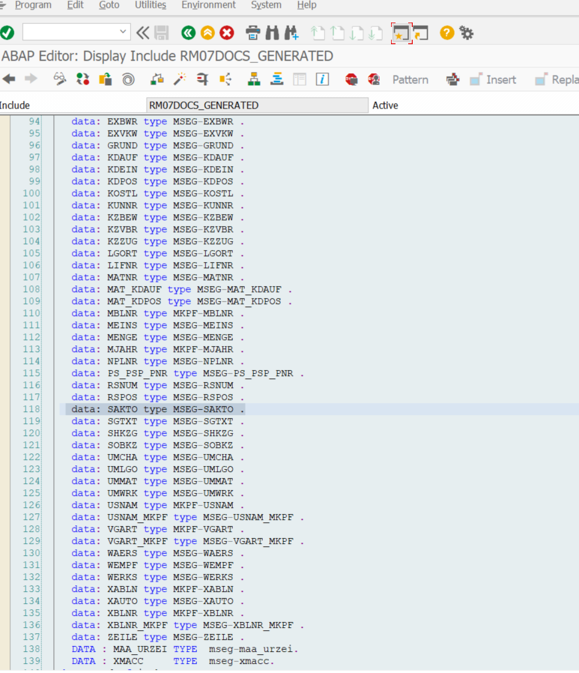

Program:RM07DOCS -> add field cat

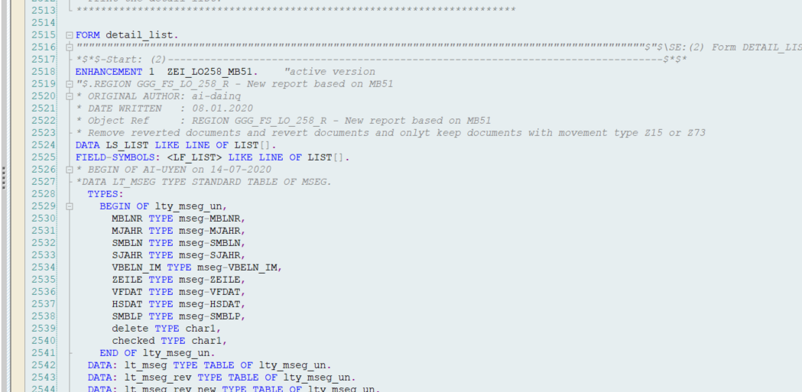

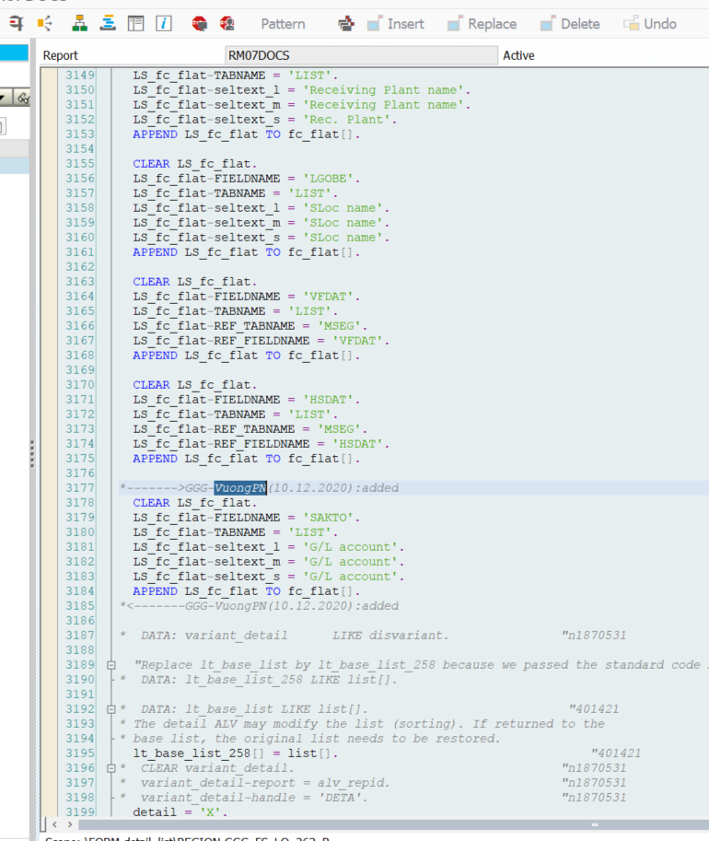

Run MB51

